Financial Informatics HW1

2013310443 최재필

* Data used:
  + S&P500 data imported from Quantmod library (2015.01.01 ~ 2018.10.07)
  + KOSPI200 from KRX & NAVER Finance (2015.01.01 ~ 2018.10.7) [failed attempt]

1. Introduction
   1. Since my proficiency on R is relatively lower, I originally intended to prototype investment model on Python and then duplicate it on R. However, prototyping took longer than expected and finance modeling on R required a totally different approach.
   2. So I had to execute most of my mock investments on Python code instead. Momentum strategy written in Python (with decent readability) can be accessed [here(S&P500)](https://github.com/jaepil-choi/2018-2_FI_hw1/blob/master/Strategy1.S%26P500.ipynb) and [here(KOSPI200)](https://github.com/jaepil-choi/2018-2_FI_hw1/blob/master/Strategy1.KOSPI200.ipynb).
   3. I tried to improve the result after the class on 10/10 but the strategy 1 was done half-baked. (Please read the R code)
2. Strategy 1: (Relative) Momentum Investment.
   1. Strategy details:
      1. First observe all firms listed in the given index (S&P500, KOSPI200, etc) for a year and select 100 firms that have the highest rate of change of price. (ΔP%)
         1. 100 is a good number because it is big enough to roughly follow the index trend but not too big to have no difference from the index. (It is also convenient to get winner/loser decile from 100)
         2. Because these firms have stronger positive momentum than the rest of the firms, they are more worthy of investment. This basket of 100 firms is my *investment universe*.
         3. Buy 100 stocks of each firm.
      2. After period *t* (here, it’s 6 month), rebalance the basket.
         1. Sort 100 firms by ΔP% and get winner decile firms and loser decile firms.
         2. Buy 10% more stocks that I’m holding for winner decile firms and sell 10% stocks that I’m holding for loser decile firms.
      3. Repeat ii
   2. Implementation:
      1. S&P500 ([CLICK](https://github.com/jaepil-choi/2018-2_FI_hw1/blob/master/Strategy1.S%26P500.ipynb) to checkout codes)

|  |  |  |  |
| --- | --- | --- | --- |
| Period | Date | Investment return (%, cumulated) | Net Profit ($, cumulated) |
| 1st* | 2017.06.28 | 16.924% | $180875 |
| 2nd | 2017.12.25 | 31.544% | $340439 |
| 3rd | 2018.06.19 | 53.849% | $581162 |

* (after *t* period from basket selection.)

* + 1. KOSPI200 ([CLICK](https://github.com/jaepil-choi/2018-2_FI_hw1/blob/master/Strategy1.KOSPI200.ipynb) to checkout codes)

|  |  |  |  |
| --- | --- | --- | --- |
| Period | Date | Investment return (%, cumulated) | Net Profit (\, cumulated) |
| 1st* | 2017.06.29 | 10.312% | \152968550 |
| 2nd | 2017.12.26 | 15.107% | \229213685 |
| 3rd | 2018.06.24 | -6.852% | \-103960300 |

* (after *t* period from basket selection.)

Why did this happen? Turned out, Naver Finance stock price was NOT adjusted. That’s why I tested the same momentum strategy on two different stock market.

1. Strategy 2: SMA (Simple Moving Average)
   1. Strategy details:
      1. First observe all firms listed in the given index (S&P500, KOSPI200, etc) for a year and select 100 firms that have the highest yearly return.
         1. 100 is a good number because it is big enough to roughly follow the index trend but not too big to have no difference from the index. (It is also convenient to get winner/loser decile from 100)
         2. Because these firms have stronger positive momentum than the rest of the firms, they are more worthy of investment. This basket of 100 firms is my *investment universe*.
      2. Make two simple moving averages (SMAs) to get the signal to buy/sell.
         1. When faster moving average penetrates beyond slower moving average, buy the given portfolio
         2. When faster moving average penetrates below slower moving average, sell the given portfolio.
   2. Implementation:
      1. S&P 500
         1. 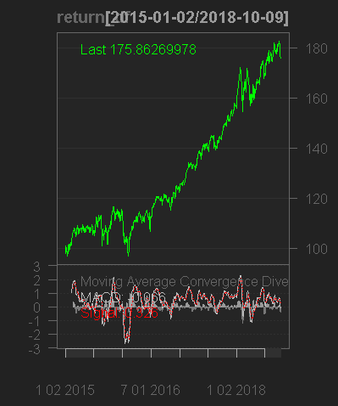  
            green is the return of portfolio and red is signal given by MACD.